**Assignment 02 – WordPress CMS Website (Basic Pages)**

**Instructions for completing template:**Replace **[bracketed red text]** with the requested information or screen capture.  
Replace **bracketed red text with black text** and then remove the brackets.  
Do not include full screen shot images, or full screen shots that are reduced in size. Use a snippet tool to capture parts of the screen and insert those images into the template.  
Do not remove tags from this template. Please answer all questions.  
**Please do not alter the formatting or delete parts of this template.**  
Assignment questions are not as detailed as activity questions.   
The assignment is where you demonstrate understanding of the material.

**Part A - Student Information**

1. **Student Name: Abel Marin [A01]**
2. **Student Contact Information: marinabe1416@gmail.com [A02]**
3. **Date you start this assignment: Friday January 17, 2020 [A03]**

**Go back to the instructions and begin work on Part B.**

**Part B - Create 1 Shared Web Host WordPress CMS Website**

(1) Shared Web Host WordPress CMS Site Information:

Shared Web Host Name: SiteGround [B01]  
cPanel URL: [Enter cPanel URL here] [B02] *Only for hosts with separate URL for cPanel  
Shared web Host or cPanel Username: amarin13@mail.depual.edu [B03]  
Shared web Host or cPanel Password: Dbeu!315 [B04]  
Domain Name: abelm.sgedu.site [B05]  
In Directory Name: mod2assign2 [B06]  
Website Admin Username: abelmarinjr [B07]  
Website Admin Password: 6uAu%&609% [B08]  
Database Name: wp608 [B09]  
Table Prefix: wpvu_ [B10]  
WordPress CMS Website URL: <http://abelm.sgedu.site/mod2assign2/> [Front End URL] [B11]

*Note: Please do not provide the Backend for B11 (above).*

-OR-

(2) Pantheon – WordPress CMS Site Information:

**Assignment Website Site Name:** **[Site Name here] [B01]**

**WEBSITE Admin Username:** **[Admin Username here] [B02]**

**WEBSITE Admin Password:** **[Admin Password here] [B03]**

**Pantheon Frontend Website URL:** **[Frontend website URL here] [B04]**

**Note: Please do not provide the Backend URL for B04 above.**

**Go back to the instructions and begin work on Part C.  
  
Part C - Extend the WP Site with Menus**

1. SCREEN CAPTURE of the **Media** Library Page **[Dashboard > Media > Library]** showing the images you added in Grid and List View  
    **[Grid A screenshot of a computer

   Description automatically generated] [C01.1]**

**[List 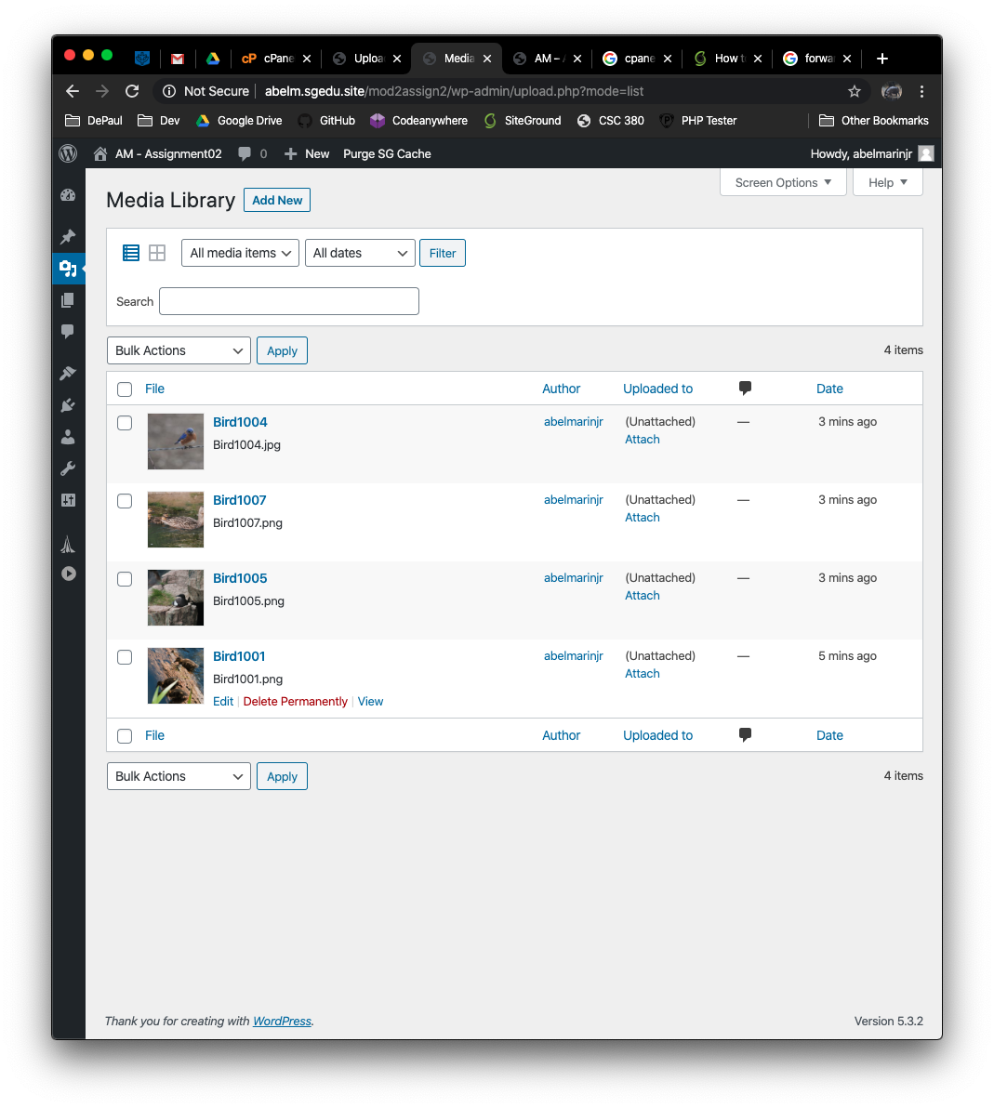] [C01.2]**

1. SCREEN CAPTURE of the **Menu** Page **[Dashboard > Appearance > Menu]** showing your Menu Name, and Menu Settings.  
   This may require multiple screen captures to show the check boxes at the bottom  
    **[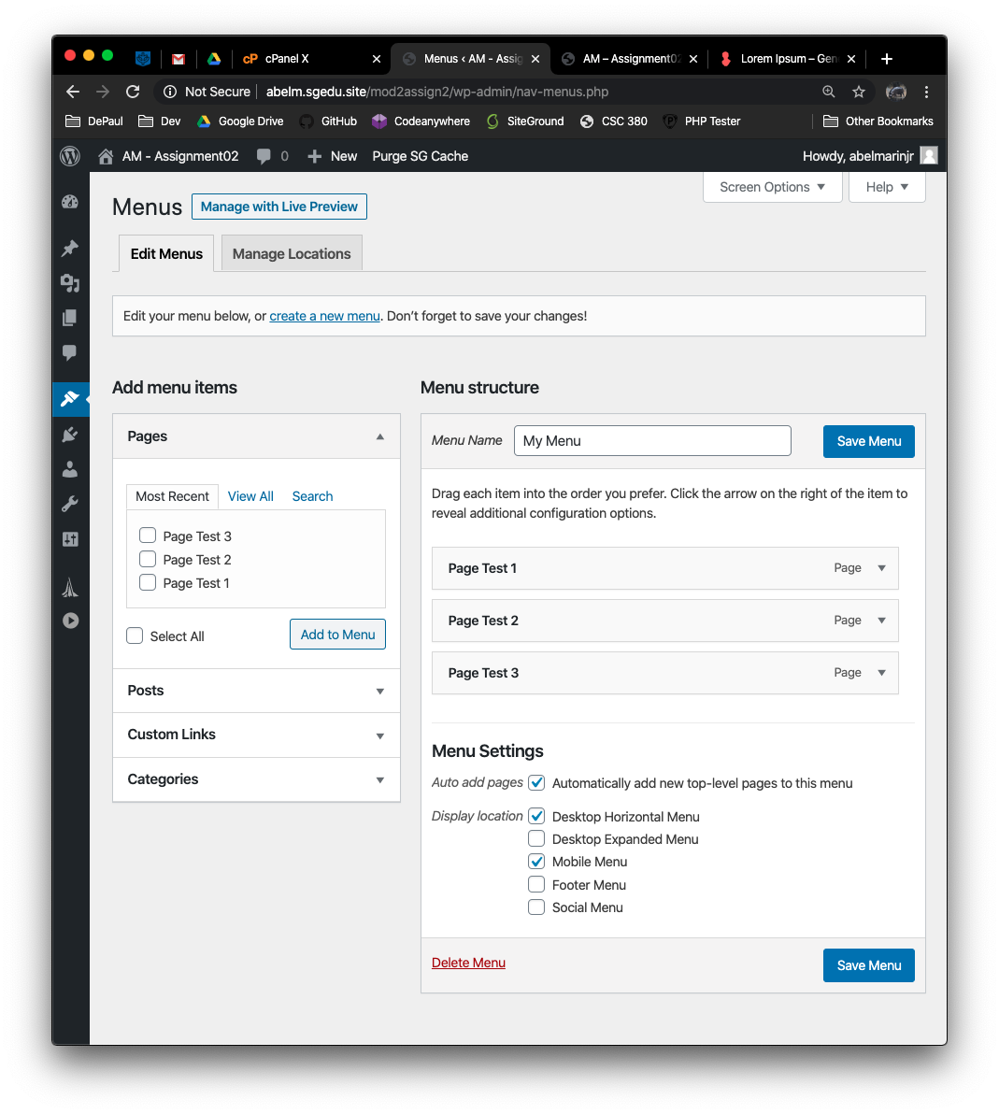] [C02]**
2. SCREEN CAPTURE of the Client Facing front end website, showing the test pages as menu items. Please make sure your screen capture shows the web browser address bar for full credit.   
   **[A screenshot of a cell phone

   Description automatically generated] [C03]**

**Go back to the instructions and begin work on Part D.**

**Part D – Create a WordPress CMS Site on Codeanywhere: (REQUIRED)**

1. **D.1 Codeanywhere account and CMS site credentials:  
   NOTE:** Codeanywhere account credentials are required so the instructor can start the Connection container in order to test the WordPress site  
   Enter the following Codeanywhere web host account and WordPress site information **[D.1]**
   1. Codeanywhere account username (email): [marinabe1416@gmail.com]
   2. Codeanywhere account password: [Dbeu!315]
   3. Site Title: [ ajmwp773 ]
   4. Website Admin Username: [ ajmarin ]
   5. Website Admin Password: [ rIVMcZPNW3JmNOW*c3 ]
2. Return to the intrusions to part D.2 and continue working

**D.2 - The screen captures for this part are from the Codeanywhere WordPress site you build and configure in Part E.**

1. **SCREEN CAPTURE of the Codeanywhere Info page. Please select and screen capture the entire web browser.  
   To display the Info page, right click on the left side connection, and select Info  
   [A screenshot of a cell phone

   Description automatically generated] [D.2-01.1]**
2. **SCREEN CAPTURE of the Codeanywhere WordPress Backend Admin site,   
   selecting Dashboard > Home   
   To display the Info page, right click on the left side connection, and select Info  
   [A screenshot of a computer

   Description automatically generated] [D.2-01.2]**
3. SCREEN CAPTURE of the **Media** Library Page **[Dashboard > Media > Library]** showing the images you added in Grid and List View  
    **[Grid A screenshot of a computer

   Description automatically generated] [D.2-02.1]**

**] [D.2-02.2]**

1. SCREEN CAPTURE of the **Menu** Page **[Dashboard > Appearance > Menu]** showing your Menu Name, and Menu Settings.  
   This may require multiple screen captures to show the check boxes at the bottom  
    **[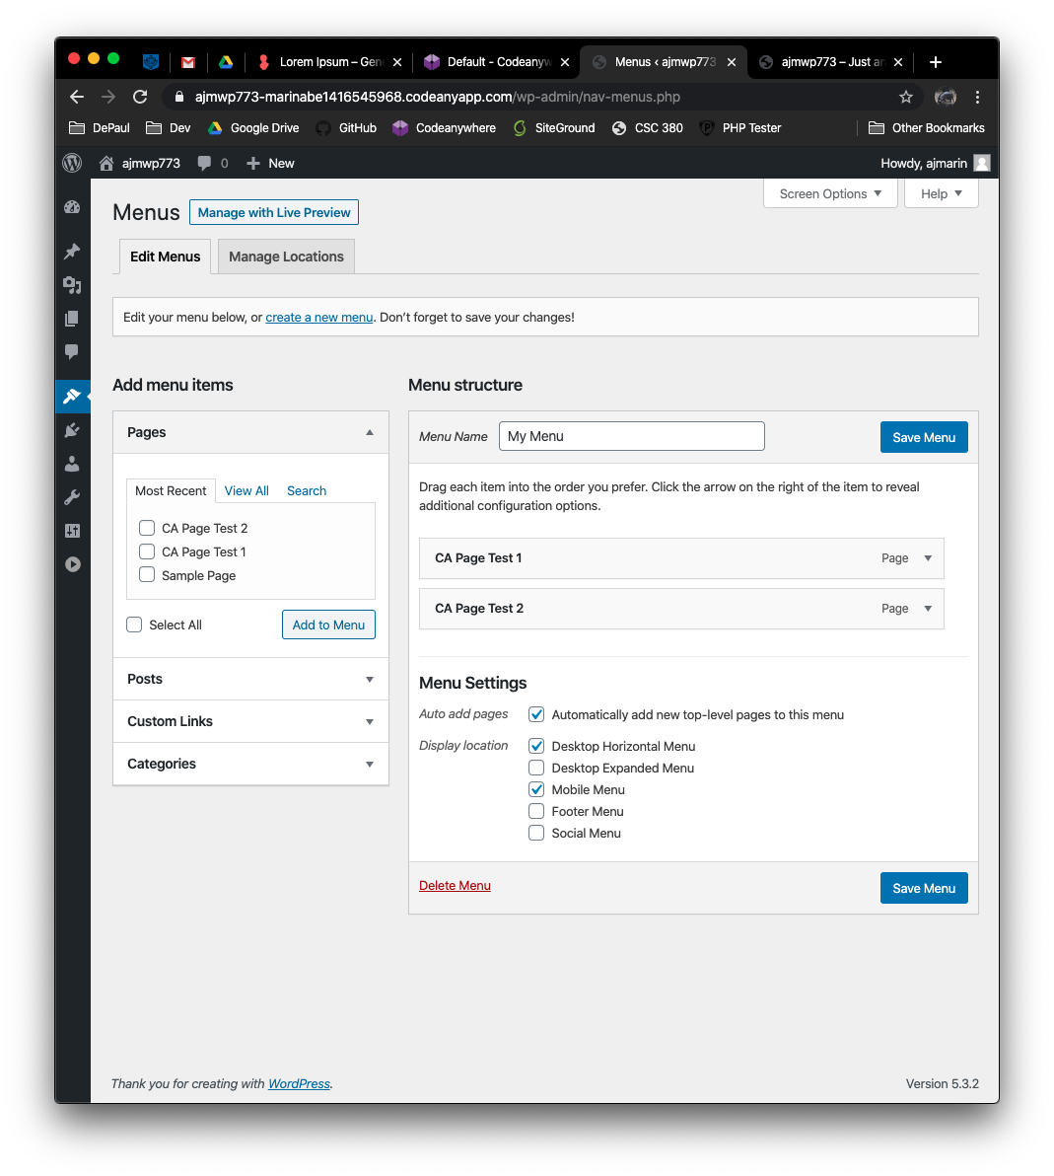] [D.2-03]**
2. SCREEN CAPTURE of the Client Facing front end website, showing the test pages as menu items. Please make sure your screen capture shows the web browser address bar for full credit.   
   **[A screenshot of a cell phone

   Description automatically generated] [D.2-04]**

**Go back to the instructions and begin work on Part E.**

**Part E - PHP Exercises:   
Testing PHP Programs using PHP Emulation Websites:**

* Online PHP test sites:
  + <http://phptester.net>
  + <http://sandbox.onlinephpfunctions.com/>
* How you test your script depends on which test site you use.
* **Each PHP emulation test site works slightly different**.
* Please read the site instructions before testing your PHP code.

1. Write PHP code that does the following:
   1. Creates 4 variables, with values 1,2,3, and 4
   2. Adds the variables together and assigns the result to a 5th variable named $result.
   3. Displays the $result value using an echo statement.

**Test your code using an online PHP test site and paste a screen shot of the tested code and results from the website emulator in the table cell below.**

|  |
| --- |
| Copy and paste the code block and record the results on the next row. A screen shot from the PHP test site will be the best way to not affect template format. Please try not to change the template numbering or format. **[E01]** |
| **Paste screen capture from PHP test website here ** |

1. Write PHP that does the following:
   1. Create 4 variables, with values “xXx”, “cAc”, “qBq”, “Bill”.
   2. Concatenates all 4 variables **using the concatenation operator** (AKA: dot operator) and assign the result of the concatenation into a 5th variable named $catResult.
   3. Displays the $catResult value using an echo statement.

**Test your code using an online PHP test site and paste a screen shot of the tested code and results from the website emulator in the table cell below.**

|  |
| --- |
| Copy and paste the code block and record the results on the next row. A screen shot from the PHP test site will be the best way to not affect template format. Please try not to change the template numbering or format. **[E02]** |
|  |

1. Write PHP that does the following:
   1. Creates 4 variables, with values “My”, “Name”, “is”, “Bill”.
   2. Concatenates all 4 variables **using the concatenation operator**, while adding a space between each one and assigns the result of the concatenation into a 5th variable named $stringCatResult.
   3. Display the $stringCatResult value using an echo statement.

**Test your code using an online PHP test site and paste a screen shot of the tested code and results from the website emulator in the table cell below.**

|  |
| --- |
| Copy and paste the code block and record the results on the next row. A screen shot from the PHP test site will be the best way to not affect template format. Please try not to change the template numbering or format. **[E03]** |
| **Paste screen capture from PHP test website here **   |

1. Write PHP that does the following:
2. Creates 2 variables, with values 12 and 3
3. Write five separate lines of code that performs an arithmetic operation on the 2 variables.

* Addition
* Subtraction (with a positive result)
* Division
* Multiplication
* Modulus

1. After performing the arithmetic operation, write code that displays the resulting value **of each arithmetic operation** without an additional variable using an echo statement.

**Test your code using an online PHP test site and paste a screen shot of the tested code and results from the website emulator in the table cell below.**

|  |
| --- |
| Copy and paste the code block and record the results on the next row. A screen shot from the PHP test site will be the best way to not affect template format. Please try not to change the template numbering or format. **[E04]** |
| **Paste screen capture from PHP test website here ** |

1. Write PHP that does the following:
2. Creates 5 variables, with values “**A**”, “**Fine**”, “**Time**”, “**To Learn”, PHP**”.
3. Write PHP code that displays each variable in a single HTML TABLE.   
   Please build the table using **the concatenation operator.**  
   Please display each word above in a row, making the HTML TABLE a 1 column 5 ROW HTML TABLE.

|  |
| --- |
| A |
| Fine |
| Time |
| To Learn |
| PHP |

**Test your code using an online PHP test site and paste a screen shot of the tested code and results from the website emulator in the table cell below.**

|  |
| --- |
| Copy and paste the code block and record the results on the next row. A screen shot from the PHP test site will be the best way to not affect template format. Please try not to change the template numbering or format. **[E05]** |
| **Paste screen capture from PHP test website here ** |

1. Write PHP that does the following:
2. Creates 6 variables, with values “**A**”, “**Fine**”, “**Time**”, “**To” , “Learn”, PHP**”.
3. Write PHP code that displays each variable in a single HTML TABLE.   
   Please display each word above in a row, making the HTML TABLE a 2 column 3 ROW HTML TABLE.

|  |  |
| --- | --- |
| A | Fine |
| Time | To |
| Learn | PHP |

**Test your code using an online PHP test site and paste a screen shot of the tested code and results from the website emulator in the table cell below.**

|  |
| --- |
| Copy and paste the code block and record the results on the next row. A screen shot from the PHP test site will be the best way to not affect template format. Please try not to change the template numbering or format. **[E06]** |
|  |

**Part F – Assignment Wrap up:**

1. **Write a few sentences on what best practices are (as discussed in the tutorial) and how to use them to find, evaluate and select WordPress plugins. [F01]**

|  |
| --- |
| **You begin by searching for plugins through either wordpress.org, by searching the marketplace within the wordpress site, searching online via google for articles on certain plugins, or through word of mouth recommendations from a colleague. When considering a specific plugin you must check, in this order, to see if it is 1) compatible with your wordpress version 2) whether or not it is actively maintained 3) whether or not it is used by a large number of websites 4) and the number and quality of reviews. If you are comparing between two very similar looking plugins then you should begin by writing out a list of all of my or my clients desired functionality. I would then conduct a gap analysis in order to compare and contrast features form these plugins. I would then test out the plugin on a test site. Lastly, I would pick the plugin which featured the most necessary functionality, and which works the best on the test sites.** |

1. **Did you have any problem or issues completing this assignment?  
   This is not an optional question.   
   [No] [F02]  
     
   If you answered yes to this question, please elaborate and be specific.  
   If you had trouble with a specific question, please identify it by number and explain what you did not understand or had problems with.  
   I can only improve this assignment with your help.**

**[List problems here] [F03] *Only if you answered yes to #2**

Submit this completed template to the correct D2L assignment dropbox.If you prefer not to navigate by hand to the D2L dropbox, take advantage of the dropbox link in the D2L this module’s section. This link will take you to the correct assignment dropbox location.